1?> In a certain code, “FRIEND” is written as “HUMJTK”, how is “CANDLE” written in that code?

EDRIRL

2?> Find the missing term?

|  |  |  |
| --- | --- | --- |
| ? | 1 | 2 |
| 21 | 22 | 40 |
| 1 | 2 | 5 |
| 20 | 23 | 43 |

2

3?>Which figure is next in the series?

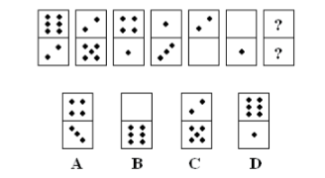

B

4?>Which fig. belongs in neither group?

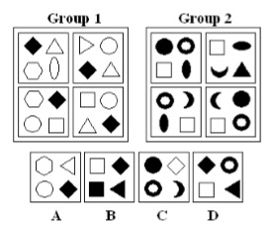

c

5?> If P $ Q means P is the brother of Q; P # Q means P is the mother of Q; P * Q means P is the daughter of Q in A # B $ C * D, who is the father?

D

6?>

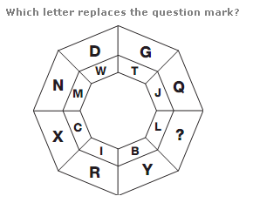

O

7?> **.** In a certain office, 1/3 of the workers are women, ½ of the women are married and 1/3 of the married women have children. If 3/4 th of the men are married and2/3 rd of the married men have children, what part of workers are without children?

11/18

8?> A, P, R, X, S and Z are sitting in a row. S and z are in the centre. A and P are at the ends. R is sitting to the left of A. Who is to the right of P?

X

9?> A cube is cut in two equal parts along a plane parallel to one of its faces. One piece is then colored red on the two larger faces and green on remaining. While the other is colored green on two smaller adjacent faces and red on the remaining. Each is then cut into 32 cubes of same size and mixed up.

How many cubes have each one red and another green?

D

10?> A man was engaged on a job for 30 days on the condition that he would get a wage of Rs. 10 for the day he works, but he have to pay a fine of Rs. 2 for each day of his absence. If he gets Rs. 216 at the end, he was absent for work for ... days.

7

11?> A software engineer has the capability of thinking 100 lines of code in five minutes and can type 100 lines of code in 10 minutes. He takes a break for five minutes after every ten minutes. How many lines of codes will he complete typing after an hour?

250

12?> A man bought a horse and a cart. If he sold the horse at 10 % loss and the cart at 20 % gain, he would not lose anything; but if he sold the horse at 5% loss and the cart at 5% gain, he would lose Rs. 10 in the bargain. The amount paid by him was Rs._______ for the horse

400

13?> Diophantus passed one sixth of his life in childhood, one twelfth in youth, and one seventh more as a bachelor; five years after his marriage a son was born who died four years before his father at half his final age. How old is Diophantus?

84

14?> Eight friends Harsha, Fakis, Balaji, Eswar, Dhinesh, Chandra, Geetha, and Ahmed are sitting in a circle facing the center. Balaji is sitting between Geetha and Dhinesh. Harsha is third to the left of Balaji and second to the right of Ahmed. Chandra is sitting between Ahmed and Geetha and Balaji and Eshwar are not sitting opposite to each other. Who is third to the left of Dhinesh?

Fakis

15?> A contractor agreeing to finish a work in 150 days, employed 75 men each working 8 hours daily. After 90 days, only 2/7 of the work was completed. Increasing the number of men by ________ each working now for 10 hours daily, the work can be completed in time.

150

16?> Five farmers have 7, 9, 11, 13 & 14 apple trees, respectively in their orchards. Last year, each of them discovered that every tree in their own orchard bore exactly the same number of apples. Further, if the third farmer gives one apple to the first, and the fifth gives three to each of the second and the fourth, they would all have exactly the same number of apples. What were the yields per tree in the orchards of the third farmer?

11

17?> If y=cos-1(cosx + 4sinx)/(17)1/2, then dy/dx is

1

18?> If “YDIN =VAFK ”. and “x=BGLQ” find x?

EJOT

19?> A landscaper estimates that landscaping a new park will take 1 person 48 hours. If 4 people work on the job and they each work 6-hour days, how many days are needed to complete the job?

2

20?> There are 3 persons Sudhir, Arvind, and Gauri. Sudhir lent cars to Arvind and Gauri as many as they had already. After some time Arvind gave as many cars to Sudhir and Gauri as many as they have. After sometime Gauri did the same thing. At the end of this transaction each one of them had 24. Find the cars Gauri originally had.?

12